Effect of Mobile phone electromagnetic waves on histological structure of liver and spleen of laboratory mice (Mus musculus)
Muhammed Ali Al-Diwan1, Shaima` Khazaal Waad2, Wissam Sajid Al-Uboody3
- Department of Physiology, College of Veterinary Medicine, University of Basra

- Department of Chemical pharmacy, College of Pharmacy, University of Al-Muthanna

- Department of Physiology & Medical Physics, College of Medicine, University of Al-Muthanna

Abstract
In the present study, histopathological changes in liver and spleen were studied to assess the effects of mobile electromagnetic waves (EMW) in mice. Two groups of twelve male mice to each were used (control and exposed groups). Male mice of the second group were exposed to (1200 MHz) (EMW) for 30 days as 6 hours daily. The results showed that different deleterious effects were caused by exposure to EMW such as pyknosis of hepatocytes, infiltration of inflammatory cells, swelling of hepatocytes and dilation of central vein. Besides, splenic changes were also clear like presence of megakaryocytes, sloughing of splenic capsule, necrosis and hemorrhage in the white pulp.
Key words: Electromagnetic waves; liver, spleen, mice.

Introduction
The increased usage of electromagnetic (EM) principles for domestic and industrial purposes proves that EMF plays an important role in our daily life. The emergence of telecommunication services using EMF principles greatly enhance the ability of individuals and groups to communicate with each other. Nowadays, phones are not only used for making and receiving calls but also for many other applications, such as banking transactions and web browsing. The world economic boom also benefitted from these technologies, the current worldwide economic crises have little or no significance to the mobile industries. According to International Telecommunication Union (ITU), the number of mobile phones subscribers in the world was estimated to about 4.6 billion in 2009, and it was expected to reach 5 billion by 2010 (1). This means that around one out of every two individuals in this world carries a mobile phone. The increased usage and growing popularity of wireless technologies in RF EMF range represent one of the fast growing environmental influences. This usage is not without a lot of controversy and public concern on the possible adverse health effect associated with the energies emitted by these technologies (2). In the advanced world of today, there is a bulk of electromagnetic-inducing devices including home electrical devices, radio, TV, and mobile phones in humans' life (3). Some studies have showed that very low frequency electromagnetic fields induct chromosomal impairments in polychromatic erythrocytes of male rat's marrow (4). Exposure to electromagnetic radiation (EMR) from mobile phones can cause detrimental effects on cell function, chromosomal aberrations, and tissue injuries (5) and (6). EMW may lead to changes in cell activity, affect the synthesis of genetic material and alter with the flow of substances in and out of cells (7). EMW also affects the histological structure of the liver (8).

Materials and Methods.
- Experimental animals.
In the present study, 24 male mice (Mus musculus), 12 weeks old, and of 20 – 25 grams weights were used. The experiment conditions were unified for all animals, where the room temperature was set between 20 – 25 C˚ by the use of air conditioners, and the humidity rate was about 50 %. Food and water were provided daily (ad libitum).

Experimental design
The animals of the experiment were divided into two equal groups of 12 male mice each. The histopathological examinations were done after 30 days of exposure. The groups were:
◙ Control group. In this group, 12 male mice were used and euthanized after 30 days for the necessary exams.
◙ Exposure group. In this group, 12 male mice were exposed to (1200 MHz) (EMW) for 6 hours daily and euthanized after 30 days for the necessary exams.
The (EMW) – electromagnetic waves – were obtained by the use of Frequency Generator (Type D 14, No. 36943. Made in Dan bridge-Denmark).

Histological Samples
Samples of liver and spleen were collected after the animals have been terminated by the use of an anesthesia then the mice were dissected in the lower portions of their abdomens. Then the following histological processes were done for the samples: Fixation stage; by the use of (10%) formalin. Washing stage; where the samples were rinsed with tap water for 2 hours. Dehydration stage; by the use of ascending concentrations of ethyl alcohol as: 70%, 80%, 90%, 90%, 100%, and 100% (2 hours for each concentration). Clearing stage; the samples were cleared in xylene solution for 1 hour. Embedding and infiltration stage; where the samples were embedded in the first paraffin wax bath for 2 hours then transmitted for the second paraffin wax bath for 1 day of infiltration. After that the samples were cast in the wax casts and left to be cold then cut by microtome to a thickness of 5 microns and affixed on glass slides and dried on a hot plate on 50 c. Staining stage; the sections were stained with hematoxilin and eosin routine stain to detect the general structure of the tissue (9) then the slides were covered with cover slips by fixing the cover slips with DPX and examined under light microscope of Olympus type

Results and Discussion

The results showed that when mice were exposed to mobile phone electromagnetic waves (EMW 1200 MHz) in average time 6 hours daily for 30 days; there were severe effects on liver tissue such as edema, dilatation of sinusoids which filled with fibrin, swelling of hepatocytes and nuclei, pyknosis and pericentral vein infiltration of inflammatory cells (pictures, 2,3). The results also revealed that EMW causes various types of damage to the spleen of the exposed animals; where the spleenic capsule was sloughed, wrinkled and separated from the tissue in some areas. There was hemorrhagic area in the white pulp which indicates hemorrhagic spleenitis. Megakaryocytes were also noticed in the white pulp beside the presence of a pale area of infarction and necrosis (picture 5 and 6). These results came in accordance with studies of (10) and (11). The above results can be explained as the effects of reactive oxygen species (ROS) on the tissues of spleen and liver which is related to the genotoxic effects of EMW on DNA and hematopoietic stem cells which insured the effects of EMW on the liver and spleen as a part of the hematopoietic system (12). There is also another mechanism by which the EMW affects different body organs and tissues; the EMW exposure heats biological tissues, resulting in a number of heat-related physiological and pathological responses in human subjects and laboratory animals (13).

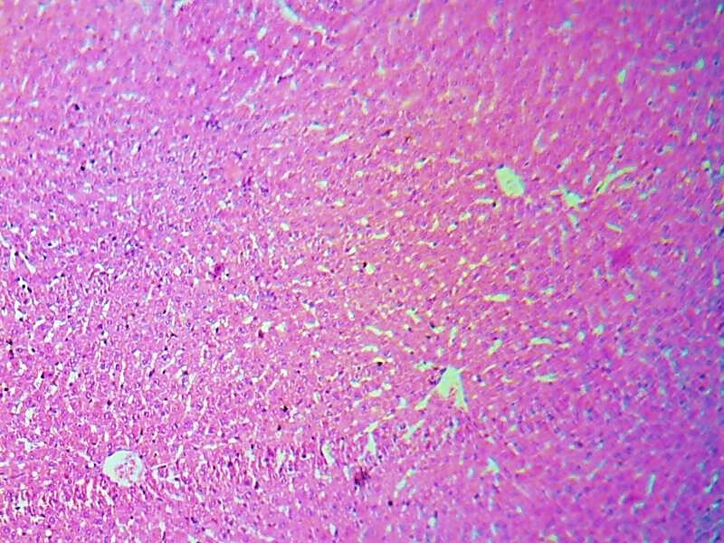
A
B

Picture (1).Control liver (H&E Stain, 10X). Normal central vein (A) and normal hepatocytes (B).

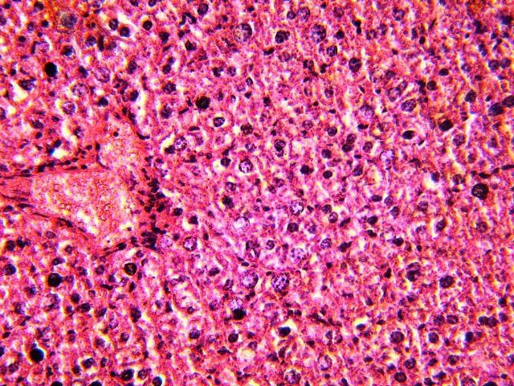
A
A
B

Picture (2).EMW exposed liver (H&E Stain, 40X). Dilated central vein (A) and swelling of hepatocytes (B).

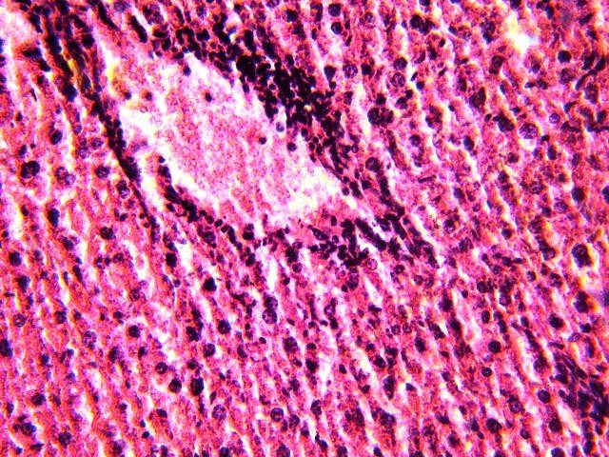
A
B

Picture (3).EMW exposed liver (H&E Stain, 40X). Pericentral vein infiltration of inflammatory cells (A) and pyknosis hepatocytes (B).

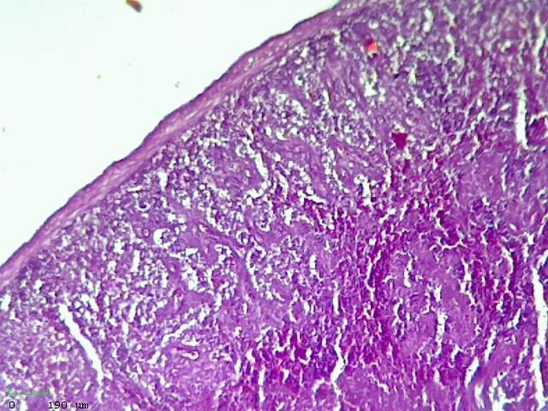
A
B
C

Picture (4).Control spleen (H&E Stain, 10X). Normal capsule (A), white pulp (B) and red pulp (C).

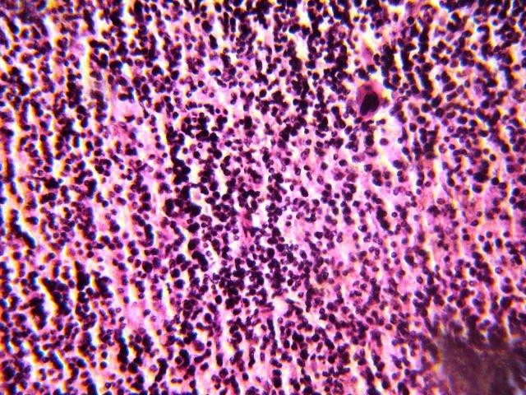
A
B

Picture (5).EMW exposed spleen (H&E Stain, 40X). Megakaryocyte (A) and hemorrhage (B).

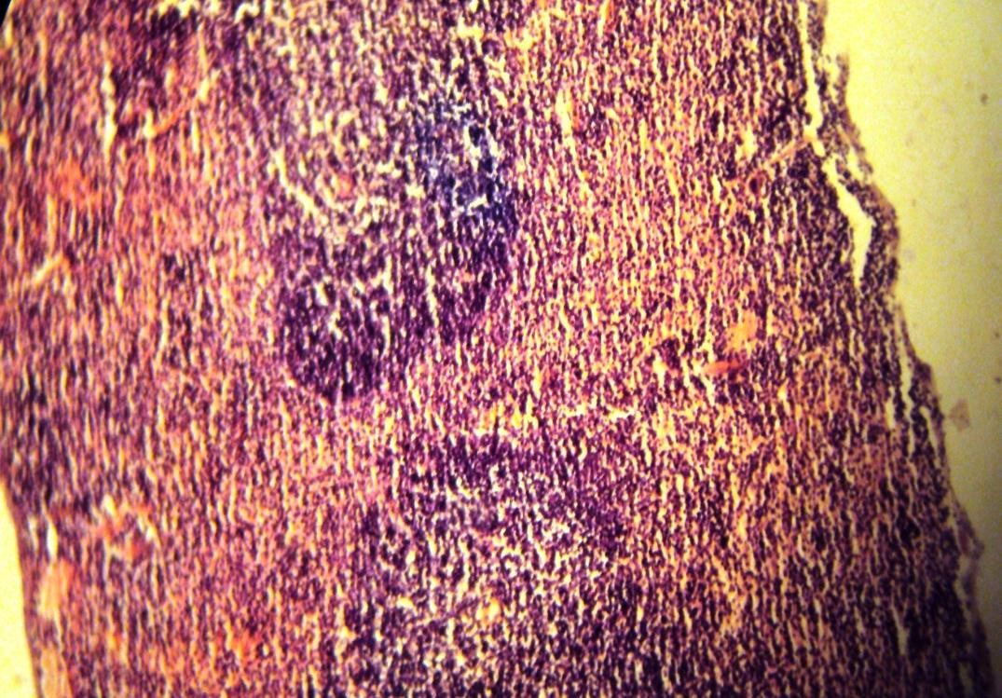
B
A

Picture (6).EMW exposed spleen (H&E Stain, 10X). Sloughing of capsule (A) and white pulp necrosis (B).

Conclusions
We conclude from the results obtained in our study that the exposure to mobile phone electromagnetic waves causes malicious effects on tissues of liver and spleen of mice.

References
- Hamadoun, T. (2010). Strong global mobile cellular growth across all regions. International Telecommunication Union Mobile World Congress, Bercelona.
- Repacholi, M. H. (1999). EMF concerns and WHO's international EMF project. International Seminar on EMF Risk Perception and Communication, 29-49, Ottawa, Ontario, Canada.
- Verschaeve, L. (2009). Genetic damage in subjects exposed to radiofrequency radiation. Mutat Res; 681(2-3): 259-70.
- Baharara, J.; Haddad, F.; and Khandehrou, A. (2008). The effect of extremely low frequency electromagnetic field (50Hz) on induction of chromosomal damages on bone marrow. AMUJ; 11(2): 19-26.
- Lai, H.; and Singh, N.P. (1997). Acute exposure to a 60 Hz Magnetic field increase DNA strand breaks in rat brain cells. Bioelectromagnetics. 18:156-165.
- Moussa, E.A. (2005). Effect of electromagnetic field on liver and kidney tissues of Swiss albino mice. J. Egypt. Ger. Soc. Zool ; 48:29-53.
- Vorst, A. V.; Rosen, A..; and Kotsuka, Y. (2006). RF/Microwave Interaction with Biological Tissues. John Wiley & Sons, Inc., New Jersey. 63-95.
- Usman, A.D.; Ahmad, W.F.WAN; Ab Kadir, M.Z.A.; Mukhtar, M.; and Ariffin, R. (2012). Microwave effect of 0.9 GHZ CW frequencies exposed to unrestrained swiss albino mice. Progress In Electromagnetics Research B, Vol. 36, 69-87.
- Luna, L.G. (1968). Manual of Histology staining method of the armed forces. Institute of pathology. 3rd ed. M.H. Graw Hill Book Co., USA, 258.
- Dogaru, Gabriela Bombonica; Crăciun, C.; Cătoi, C.; Toader, S.; and Pop,L. (2007). Histological changes in organs and tissues of rats undergoing pulsed short waves treatment. Annals or RSCB, Vol. XIV, Issue 2, 73-79.
- Baharara, Javad; Mahdavi-Shahri, Naser; Zafar-Balanejad, Saeedeh; and Kamareh, Esmat (2012). The Inhibitory Effect of Camellia sinensis Extract on Decreasing Inductive Teratogenicity of Low Frequency Electromagnetic Field in Liver and Spleen of Balb/C Rat Embryo. Zahedan Journal of Research in Medical Sciences; 14(5): 1-6.
- Lai, Henry. (2012).Genetic Effects of Non-Ionizing Electromagnetic Fields.Biointiative Working group, Section 6; 1-59, USA.
- Vecchia, Paolo; Matthes, Rüdiger; Ziegelberger, Gunde; Lin, James; Saunders, Richard; and Swerdlow, Anthony. (2009). Exposure to high frequency electromagnetic fields, biological effects and health consequences (100 kHz-300 GHz). International Commission on Non-Ionizing Radiation Protection . 1-355, Germany

